RSMC – Nadi
AIFS – Hydrology Raw Data Filtering Program Specification
August 1999

Version 1.0 draft 1
AIFS – Hydrology Raw Data Filtering Program Specification, version 1.0 draft 1

Date of Issue: August 1999

Copyright: © 1998 by Commonwealth Bureau of Meteorology
All rights reserved. No part of this document may be reproduced by any means or in any form without the express permission of the Commonwealth Bureau of Meteorology.
This documentation was prepared for Commonwealth Bureau of Meteorology by:
Phil Nguyen
Hydrology Unit – Flood Waring Program Office

Table of Contents
Background 4
Analysis 5
Roll-over Data 5
Noise Data 5
System Design 6
Algorithm 6
Establish Start Continuity 7
Establish Continuity 12
Object Design 15
hyFilter 15
Implementation 17
Testing 18
Creating Data File 18
Executing 357-Filter program 18
APPENDICES 19
REFERENCES 19

Background
The rainfall and water height data (event time series data) collected from the observation stations via the ERTS (Event-reporting Radio Telemetry System) protocol may contain noise, missing data (during transmission) or roll-over data (when accumulator value reaches the limitation of the observation hardware device). These data could confuse the forecasting systems and produce incorrect forecasting results. The raw observation filtering process is used to improve the quality of observation data from ERTS. The filtering process applies the 3-5-7-filter algorithm to detect and remove bad data from the ERTS data based on the continuity pattern of the data set.
This 3-5-7-filter algorithm is reproduced from the existing C program that is used in ALERT Data Collection named contest357.
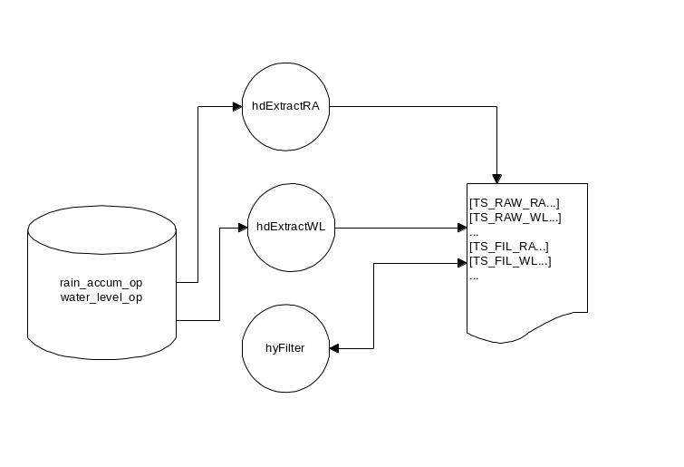

Fig. 1 Data Flow Diagram of raw data filtering process and the related components
The filtering program retrieves raw data (RainAccum, WaterLevel) from the AXF file that does the filtering process and stores the filtered data back to the AXF file in the filtered section (see Fig. 1).

Analysis
The ERTS (Event-reporting Radio Telemetry System) data is generated in a continuous form. The continuous form of the ERTS data is often broken due to the presence of noise, loss of data and interruption of data transmission. The filter process has to identify and remove noise data, adjust rollover data and establish the continuity of data. Therefore the filter process should not simply compare the difference between the data but it should also test for the data patterns when making a decision whether or not to accept the suspect data.
For example, a large gap of the data may not always indicate an error but it could be an interruption of the transmission over a long period of time. In this case, the continuity of the data is broken and the filter process has to re-establish a new set of time-series data. Any four or more consecutive data will form a continuous set of data.

Roll-over Data
The ERTS observation devices can only count from 0 to 2047. Therefore, the accumulator value will be rolled over to 0 after it reached the cycle size of 2047. In some cases, the data is rolled over before it has reached the cycle size because the observation devices were deliberately reset.

Noise Data
Noise data may occur due to interference during transmission or due to faulty observation equipment. Noise data can be a single spike or a group of spike data (refer to A continuity filter for ERTS data).

System Design
The 357-filter utility program consists of a filter driver program and a filter library.
The filter driver program provides a command line interface that gets the input arguments from the user. It then loads the data from the AXF file and invokes the filter library to filter the data and write the filtered data back to the AXF file.
The filter library accepts the data set from the filter driver program then goes along the data set and marks all bad data before returning the data set back to the caller. The bad data is not physically removed in the filter library but in the filter driver program.

Algorithm
The filter algorithm has two components: Establish Start Continuity and Establish Continuity. The Establish Start Continuity component is involved at the beginning of a time series (when the program is started or the continuity of a time series data is broken). The Establish Continuity component is involved right after the start continuity of a new series data has been established (see Fig.2).

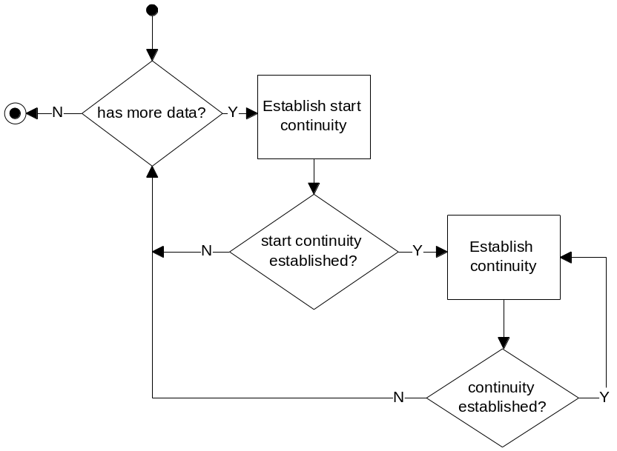
Fig. 2 Top level flow chart of the 357-filter process

Both Establish Start Continuity and Establish Continuity components use different combinations of 357 tests to determine which data should be removed from the data set. A data item that passes the 357 test if its value is <= 3 when compared with the next data or <= 5 when compared with the next-next data or <= 7 when compared with the next-next-next data.
There are three types of data used in the Filter 357 algorithm:
- Good data – The data that passes the 357 test. This data will be kept after the filter process.
- Bad data – The data that fails the 357 test and other subsequent tests. This data will be removed after the filter process.
- Suspect data – The data that fails the 357 test and is waiting for other subsequent tests. This data will become good data if it passes subsequence tests or will become bad data if it fails the subsequent tests.
If the data is marked as Bad then it will be ignored and will not be involved in any further 357 test or subsequent tests.
Data is stored in ascending time order with the latest data at the end of the list. The Filer 357 algorithm starts from the end and finishes at the beginning of the data list.
The 357 test involves two data on the list for the test. The data item being tested is called Current Data. The adjacent data item toward the end of the list is called Next Data. The adjacent data item toward the beginning of the list is called Previous Data.

Establish Start Continuity
The Start Continuity (beginning of a data series) is established when there are at least 4 good data items in the data set (see Fig. 3a). No more than 3 bad data in a group can occur in the Start Continuity window (see Fig. 3b-e).
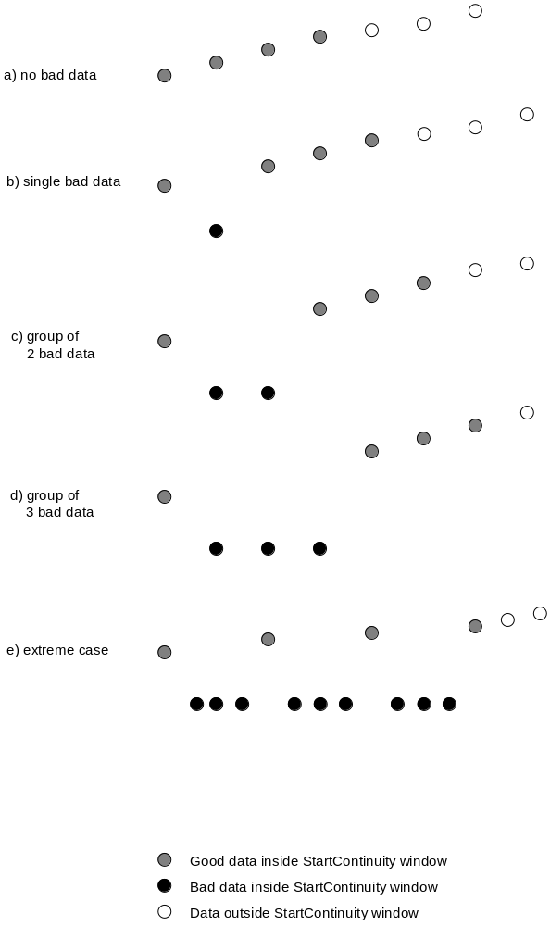

Fig. 3(a-d) Different bad data patterns may occurred in the StartContinuity window
The Establish Start Continuity starts at the end of the list. The current data will be tested with the start data. If the difference between current data and start data is not greater than 3 then the current data is marked as good. The value of current data is then obtained from the previous position and will be tested with the start data. If the difference between current data and start data is not greater than 5 then the current data is marked as good. The value of current data is then obtained from the previous position and will be tested with the start data. If the difference between current data and start data is not greater than 7 then the current data is marked as good. At this stage, the Start Continuity is established because there are 4 good consecutive data on the list. The Establish Continuity will continue the test from the current position until the continuity is broken again or no more data on the list (see Fig. 4).
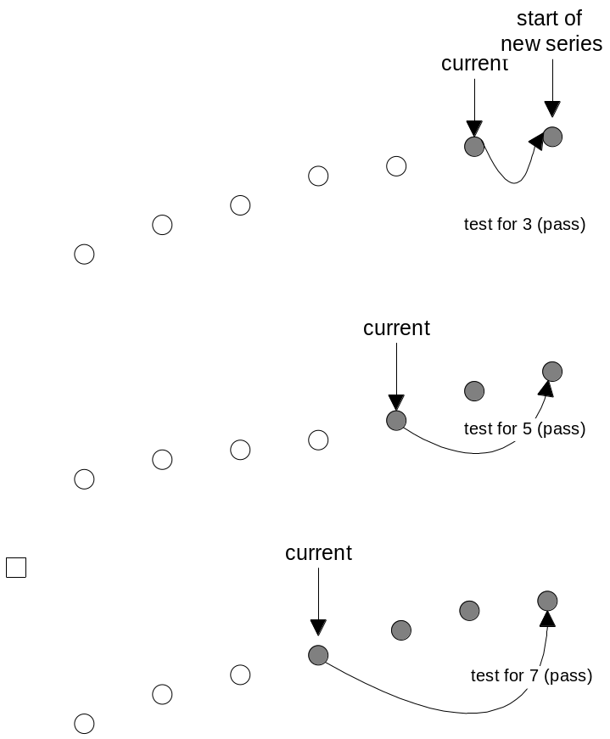

Fig 4 Establishing Start Continuity

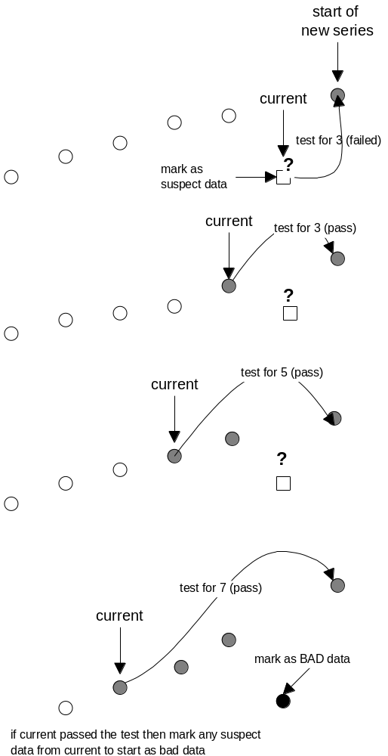

Fig 5 Establishing Start Continuity with bad data

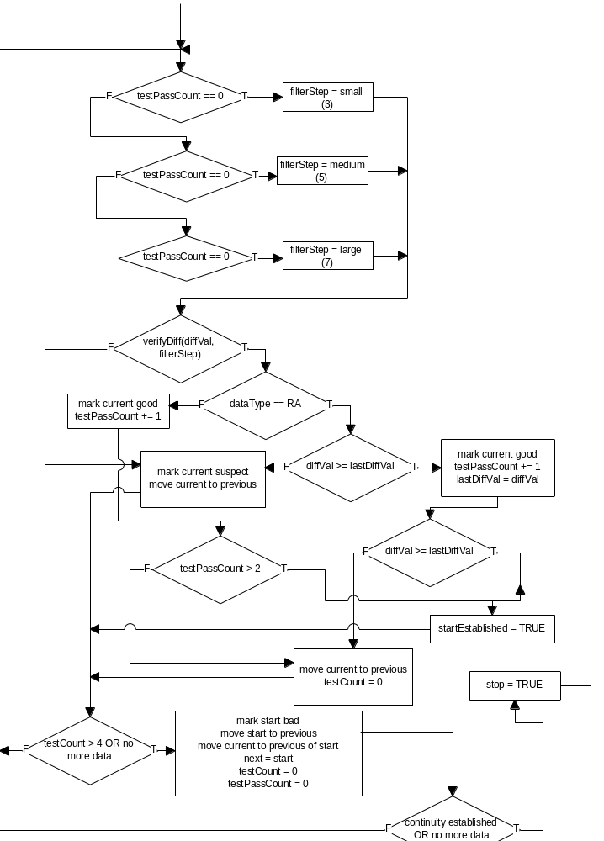
Fig 6 Flow Chart of Start Continuity Algorithm

Establish Continuity
The Establish Continuity process is involved right after the start continuity has been established. If the current data fails the 357 test with the next data in small step (3) then it will be tested with the next-next and next-next-next data for medium step (5) and large step (7). If all the tests are failed the current data is marked as suspect and the current data for the next 357 test will be the previous of the suspect data. If the current data passes the test then all suspect data from the current to “last good” data will be marked as bad (see Fig.7). The continuity is broken if 4 consecutive data fail the 357 test (see Fig. 8). The data list will be handed over to the Establish Start Continuity process for re-establishing a new time series (start from the first failed data).

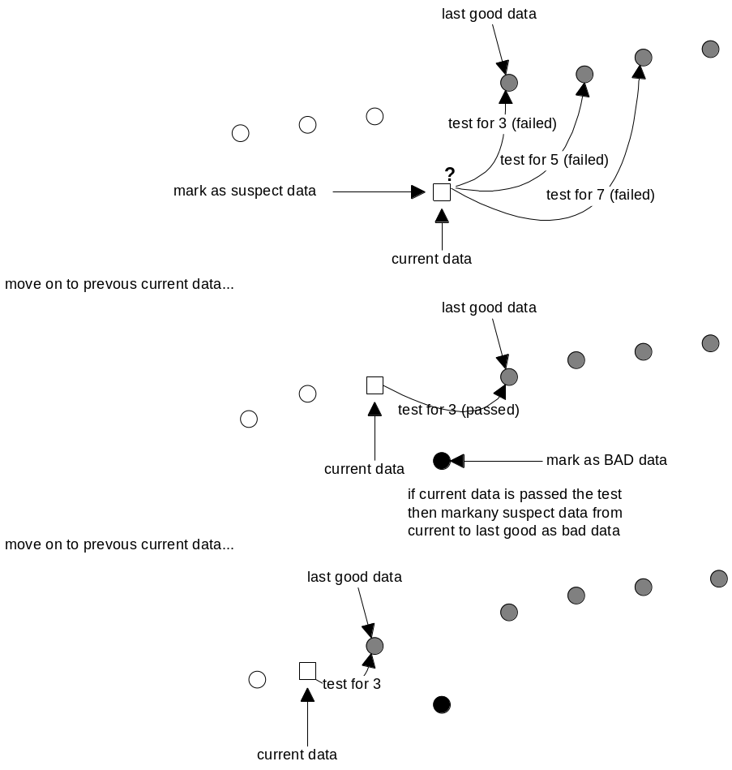
Fig. 7 Establishing Continuity

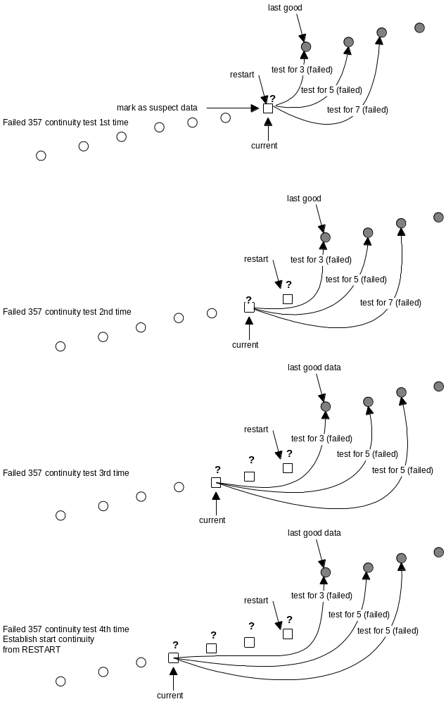
Fig. 8 A new data series will be established after 4 consecutive 357 tests failed

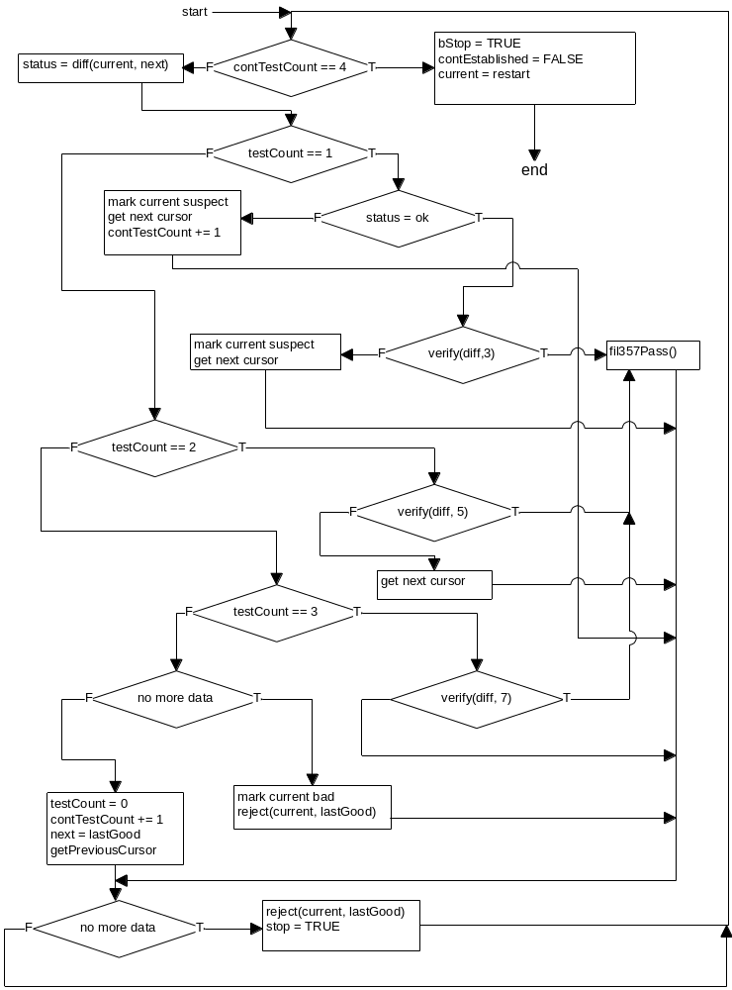

Fig. 9 Flow Chart of Establish Continuity Algorithm

Object Design

hyFilter

Base Class:

None

Attributes:
Name | Type | Description
aGenericRawList | HyList<hyGenericRaw> | A list of GenericRaw
aRainAccumList | HyList<hyRainAccum> | A list of RainAccum
aWaterLevelList | HyList<hyWaterLevel> | A list of WaterLevel
smallStep | int | Small step filter (3)
mediumStep | int | Medium step filter (5)
largeStep | int | Large step filter (7)
cycleSize | long | Limit value for counter (2048)

Methods:
Name | Return Type | Description
Filter357() |  | Constructor
establishStartContinuity() | int | Establish Start Continuity
establishContinuity() | int | Establish Continuity
filterOutOfSyncDate() | int | Remove data that has out of sync. date
fil357Pass() | int | Mark current data as GOOD and mark any suspect data from current to last good as BAD
verifyDiff() | int | Return TRUE if different value is not greater than the given step test (3-5-7)
diff() | int | Calculate different value of the 2 data according to data type (RA or WL)
adjustRolloverData() | int | Adjust the roll-over data
deleteBadData() | int | Go through the list and delete any data has status as BAD
getPreviousCursor() | int | Get previous position of the given position (skip BAD data)
getNextCursor() | int | Get next position of the given position (skip BAD data)
isAtFirst() | int | Return TRUE if given position is at the beginning of the list
isAtLast() | int | Return TRUE if the given position is at the end of the list
mark() | int | Mark the given data with (Good, Suspect or Bad) status
reject() | int | Mark any suspect data as bad data from the given start and end positions
convertToGenericRawList() | int | Convert RA or WL list into GenericRaw list
convertFromGenericRawList() | int | Convert GenericRawList into RA or WL list

